**international communications**

**30-day media report – Research article**

**Original paper:**

I: Effect Modifications of Overhead-View and Eye-Level Urban Greenery on Heat–Mortality Associations: Small-Area Analyses Using Case Time Series Design and Different Greenery Measurements

II: Effects of the urban landscape on heatwave-mortality associations in Hong Kong: comparison of different heatwave definitions

**Journal:**

I: Environmental Health Perspectives

II: Frontiers of Environmental Science & Engineering

**Authors:**

I: Jinglu Song, Antonio Gasparrini, Thomas Fischer, Kejia Hu, and Yi Lu

II: Jinglu Song, Yi Lu, Thomas Fischer, Kejia Hu

**Date Published:**

I: 20 September 2023

II: 4 September 2023

**DOI:**

I: 10.1289/EHP12589

II: 10.1007/s11783-024-1771-z

**Title of press release:** Green spaces can save lives, according to urban big data

**Date Published:** 3 November 2023

**URL:** <https://www.xjtlu.edu.cn/en/news/2023/11/green-spaces-can-save-lives-according-to-urban-big-data>

**Total number of unique readers of the media outlets that picked up the article per month:**

12,192,466

**Number of media outlets that picked up the media release (not including Chinese outlets):**

7

**Languages the article has been translated into (not including Chinese):**

Spanish, French

**Altmetric score:**

The Altmetric Attention Score for a research output provides an indicator of the amount of attention that it has received. The score is derived from an automated algorithm, and represents a weighted count of the amount of attention we've picked up for a research output.

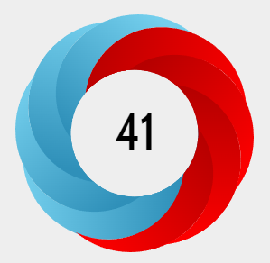

**I: In the top 4% of all research outputs scored by Altmetric.**

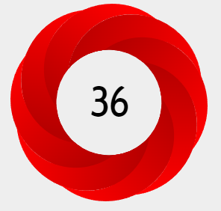

**II: In the top 5% of all research outputs scored by Altmetric.**

Thanks for your support and we look forward to working with you again!

The International Communications Team